Plan View

186 m

0 m

360 m

FBP X

FBP Y

FBP Z

FCS X

FCS Y

FCS Z

Fire line

Road

360 m

160 m

Experiment collection area 1.83 m2

|  |  |  |  |  |  |  |  |  |
| --- | --- | --- | --- | --- | --- | --- | --- | --- |
| Index | Domain size | Grid | Particle density: Pcs/m2 | | | Flux: pcs/m2.s | | |
| FCS X | FCS Y | FCS X | FCS X | FCS X | FCS Z |
| Exp | NA | NA | 335 | 463 | 536 | 0.824 | 0.902 | 1.361 |

Firebrand collection area 10 m x 10 m

|  |  |  |  |  |  |  |  |  |
| --- | --- | --- | --- | --- | --- | --- | --- | --- |
| Index | Domain size | Grid | Particle density: Pcs/m2 | | | Flux: pcs/m2.s | | |
| FCS X | FCS Y | FCS Z | FCS X | FCS Y | FCS Z |
| 1 | 360 m x 160 m x 120 m | 2 m | 29 | 180 | 552 | 0.071 | 0.350 | 1.399 |
| 2 | 360 m x 160 m x 120 m | 1m | 18 | 100 | 722 | 0.045 | 0.196 | 1.832 |
| 3 | 360 m x 160 m x 180 m | 2 m | 16 | 224 | 585 | 0.040 | 0.436 | 1.484 |

Firebrand collection area 2 m x 2 m

|  |  |  |  |  |  |  |  |  |
| --- | --- | --- | --- | --- | --- | --- | --- | --- |
| Index | Domain size | Grid | Particle density: Pcs/m2 | | | Flux: pcs/m2.s | | |
| FCS X | FCS Y | FCS Z | FCS X | FCS Y | FCS Z |
| 4 | 360 m x 160 m x 120 m | 1m | 35 | 494 | 643 | 0.086 | 0.963 | 1.632 |
| 5 | 360 m x 160 m x 180 m | 2 m | 14 | 919 | 589 | 0.034 | 1.791 | 1.495 |

|  |
| --- |
|  |

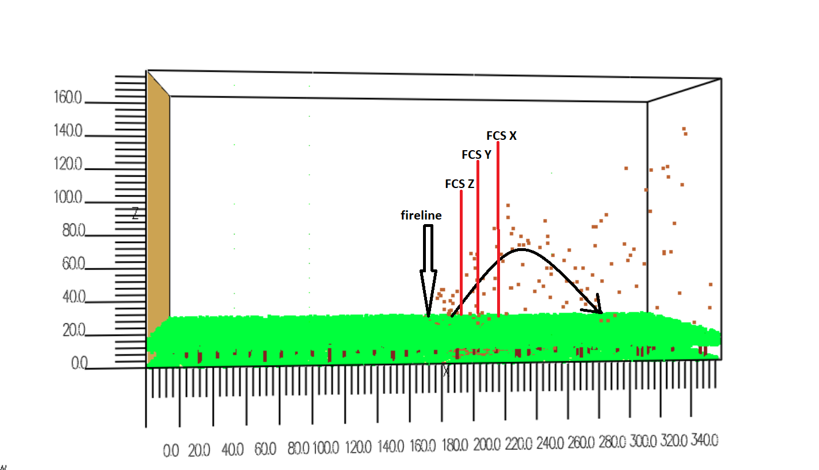

1). Plotting **forest fire** HRR and input number of firebrands in the same plot.

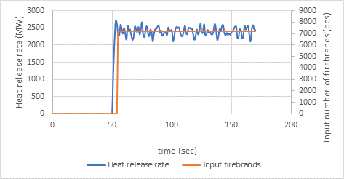

Here I input 7223pcs/s. This is the adjustment for current firebrand flux on the firebrand collection sites. According to the calculation **input number vs HRR is 3.008 pcs/MW**.

Input number vs HRR of **single tree** (with Haider and Levenspiel drag model) is **5.61 pcs/MW**

Forest fire simulation

Characteristic fire size:

$$D^{*}={(\frac{Q^{0}}{ρ_{∞}C_{p}T_{∞}\sqrt{g}})}^{\frac{2}{5}}$$

$Q^{0}$ =fire size (kw)

$Q^{0}$ = 9230 kW/m2 x 130 m x 2m = 2 399 800 kW

=1.193 kg/m3

=1 kJ/kg.K

=286 K

G=9.81 m/s2

=21.9045 m

|  |  |  |  |
| --- | --- | --- | --- |
|  | $$\frac{D^{*}}{δx}=4$$ | $$\frac{D^{*}}{δx}=12$$ | $$\frac{D^{*}}{δx}=16$$ |
| $$δx$$ | 5.48m | 1.83 m | 1.37m |

Near field and far field

Wind velocities

Velocity devices at 0 m, 1m, 2 m, 3 m, 4 m, 5 m, 6 m, 7 m, 8 m, 9 m, 10 m, 15 m, 20 m, 30 m, 40 m, 50 m, 60 m, 70 m, 80 m, 100 m, 120 m, 140 m, 160 m, 180 m heights.

|  |
| --- |
|  |
|  |

Velocity device locations



    
    
    
    